
Asset Type Tree Template – User Testing

The Goal
Our goal for this user test was to create a layout for the Asset Type Tree Template, which could also be carried easily across List and Column view.
The template needed to show all data at a glance, flow well, adapt in terms of device sizing and still translate as a tree view.

Current Comments
The general consent was that most users were happy with the current layout of the template. The need to keep the relational hierarchy was also very important.

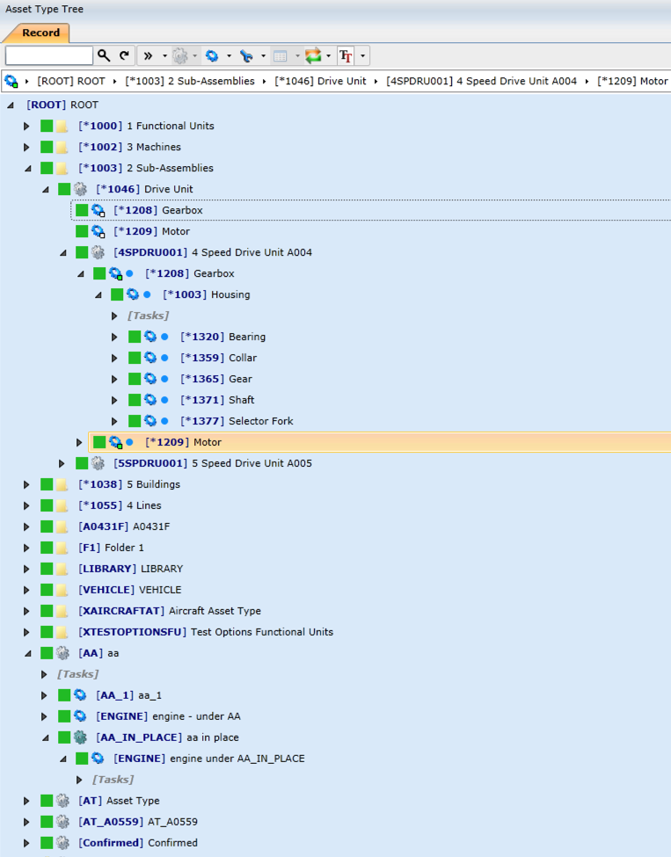

The User Testing
Out of a total of 6 designs, I have taken the top 3 that were tested among 5 different users ranging from using OnKey daily, to those who aren’t too familiar with the functionality of OnKey

Users
Stefan Swannepool
Nicolaas Jackson
Francine Engelbrecht
Emil Munro
Johan Hendricks

The Templates
The following content was used on all the designs but depicted in different ways on each design:
Icon, Status, Inheritance, Code and Description.

Option 1
This is the current tree view template

Option 2
This shows the status as text and the inherit as an icon below the code and description

Option 3
This shows the status, inherit and the icon in a grid below the code and description. The status and the description are in-line

Option 4
This is with all the content below as icons

Option 5
This is with all the content below as text

Option 6
This is with the Code, Description and icons all on separate lines.

Templates In Context
Below are the top 3 mock ups with the templates in a tree view.

Option 1
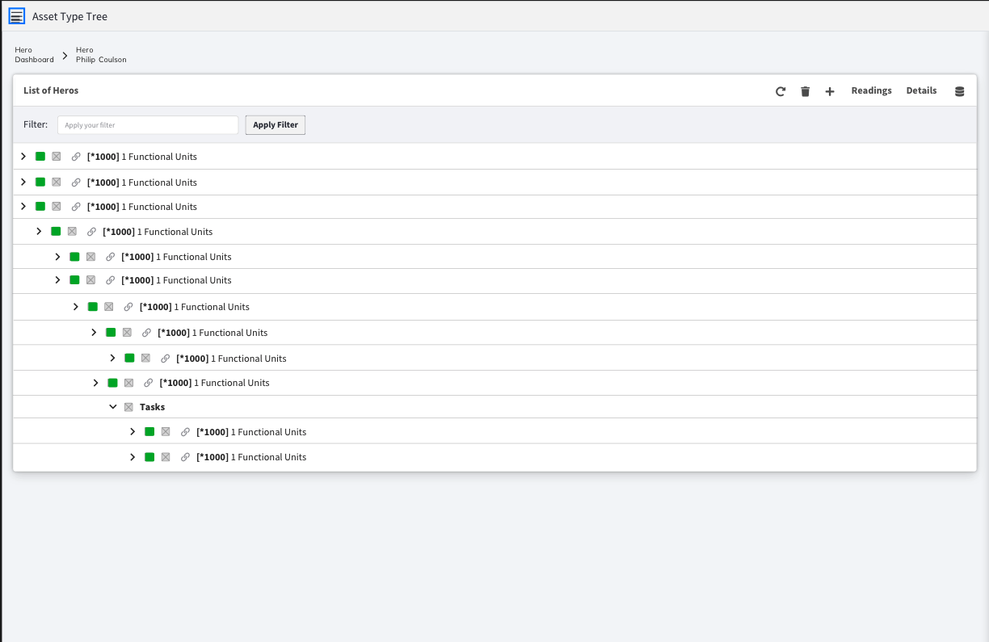

Option 4
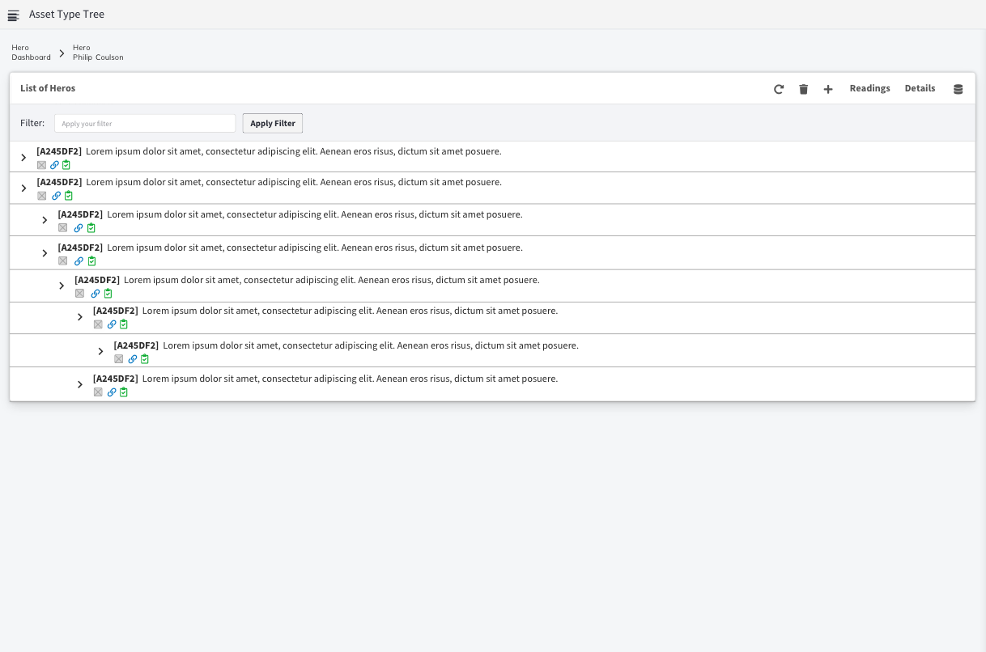
Option 6
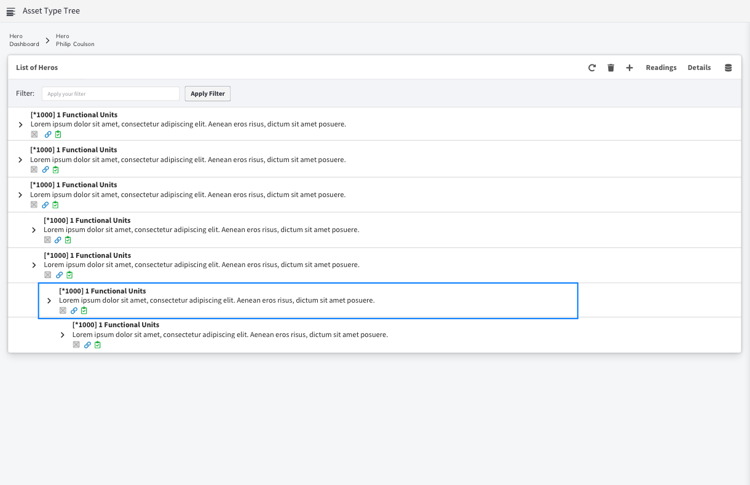

User Testing Results
We ran the designs through 5 users allowing them to mark each out of 10 as well as leave some pro’s and cons for each.

 | Option 1 | Option 2 | Option 3 | Option 4 | Option 5 | Option 6
Stefan | 8 | 5 | 5 | 6 | 5 | 4
Nicolaas | 8 | 4 | 4 | 4 | 3 | 0
Francine | 8 | 0 | 0 | 10 | 0 | 5
Emil | 4 | 6 | 6 | 8 | 4 | 8
Johan | 5 | 6 | 5 | 7 | 4 | 7
 | 33 | 21 | 20 | 35 | 17 | 24

The user testing showed a reluctance in some to divert from the original template while majority were happy to see some change.

Option 4 came out top followed by Option 1 and then Option 6.

Some of the comments for the above options

Option 1
Pro’s | Con’s
- Compact Rows  - All in one line  - The icons in a line are easy to follow as you scroll down  - Same as OK 5  - Functional quick and easy view  - People are use to this | - Feels like not enough info  - Needs an update (old)  - People are use to this, What is new

Option 4
Pro’s | Con’s
- Compact Rows  - Like the split between assets and icons  - Easy legible  - Icons instead of clunky text  - Like the icon approach | - Icon based makes it more compact  - Might be long if all expanded  - Need to figure out a nice flow for the info

Option 6
Pro’s | Con’s
- Like the split between code, design and icons  - Quick look at Asset Types  - Icons instead of clunky text  - All info required on one screen  - Clear flow of info | - Too big if all expanded  - Overwelming  - Could fill up the screen quick  - Feels like this could be a default option

Conclusion
Option 4 came out with the highest score, but overall the templates each had their pros and cons. A lot of comments for having all of the templates as a selectable option was made. Users liked the idea of choice

